Python DA Assignment 2 - Data Visualization
1) Loading the Taxis Dataset
import seaborn as sns
# Load the 'taxis' dataset
df = sns.load_dataset("taxis")

PYTHON CODE WITH OUTPUT

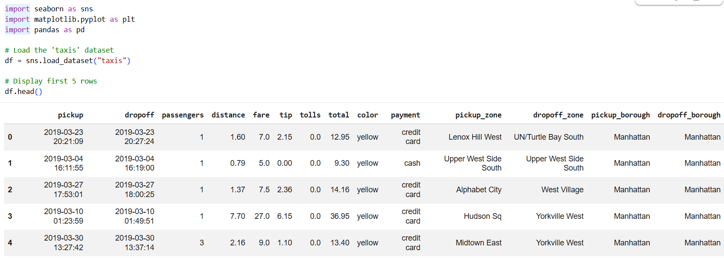

2) Handling Missing Values
➢ Check for missing values in the dataset and identify columns with missing data.
➢ Impute missing values using appropriate strategies based on the column type (e.g., using mean, median, or mode for numerical columns, and mode for categorical columns).
➢ For columns that are critical and cannot be reasonably imputed, remove rows with missing values to maintain data integrity.

PYTHON CODE WITH OUTPUT

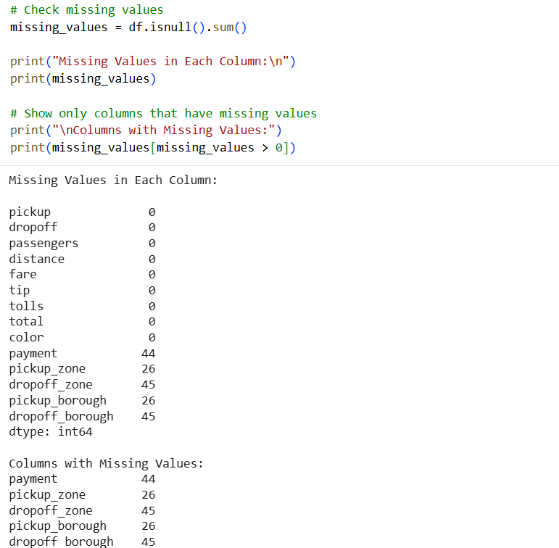

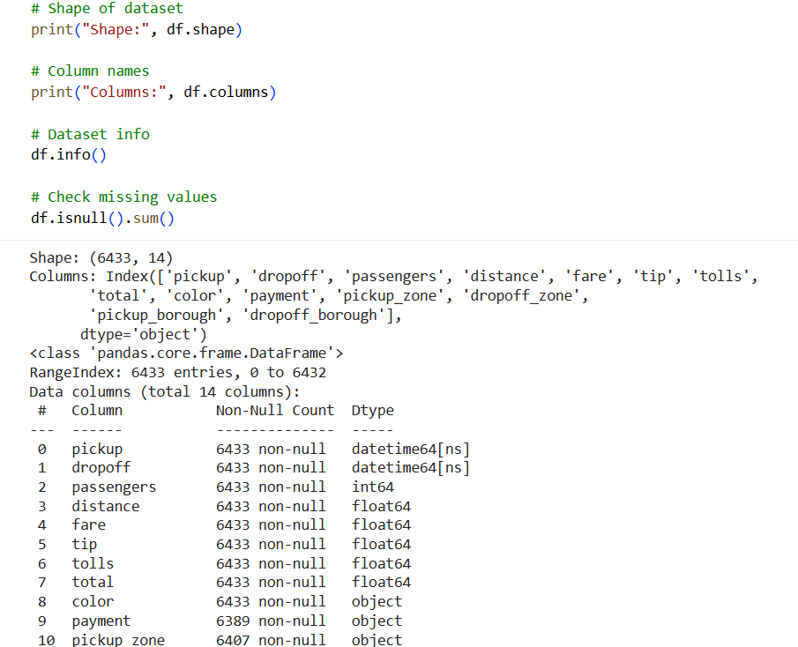
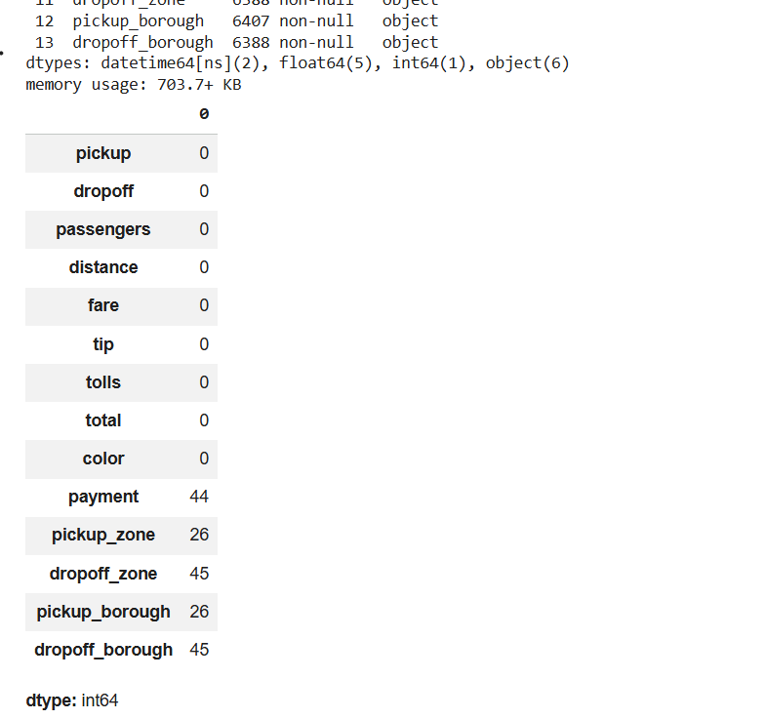
3) Visualizations using Matplotlib/Pandas Plot:
★ Line Chart
Plot a line chart to visualize the fare over time, using the pickup timestamp as the x-axis and fare as the y-axis. Ensure the pickup column is converted to a datetime format before plotting.

PYTHON CODE WITH OUTPUT
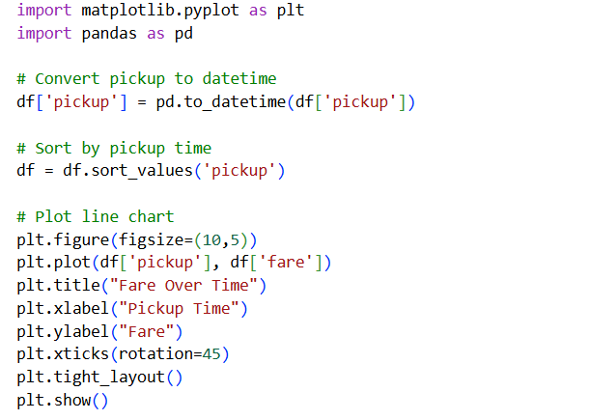
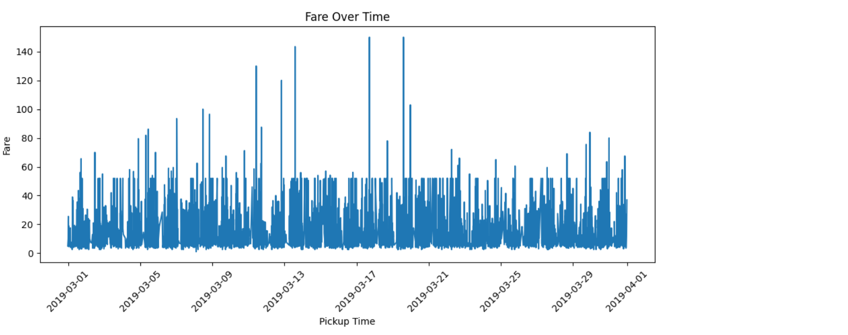
★ Bar Chart
Create a bar chart to show the total fare for each pickup_borough. Group the data by pickup_borough and sum the fare for each group.
PYTHON CODE WITH OUTPUT
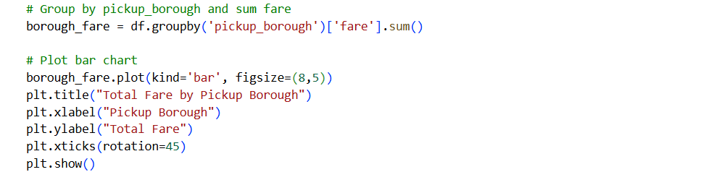
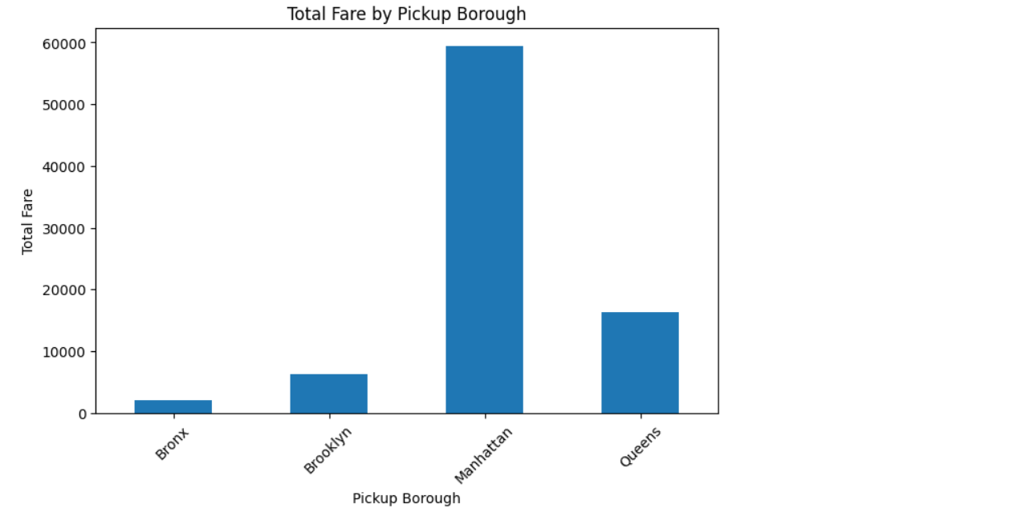

★ Pie Chart
Plot a pie chart showing the distribution of trips based on the payment method (credit card, cash, etc.). Each slice should represent the count of trips for a specific payment method.

PYTHON CODE WITH OUTPUT
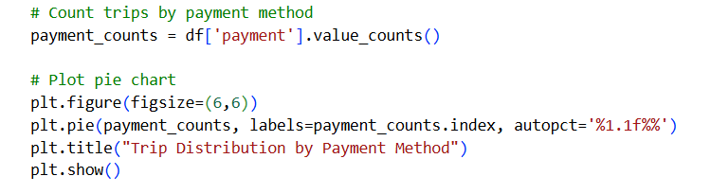
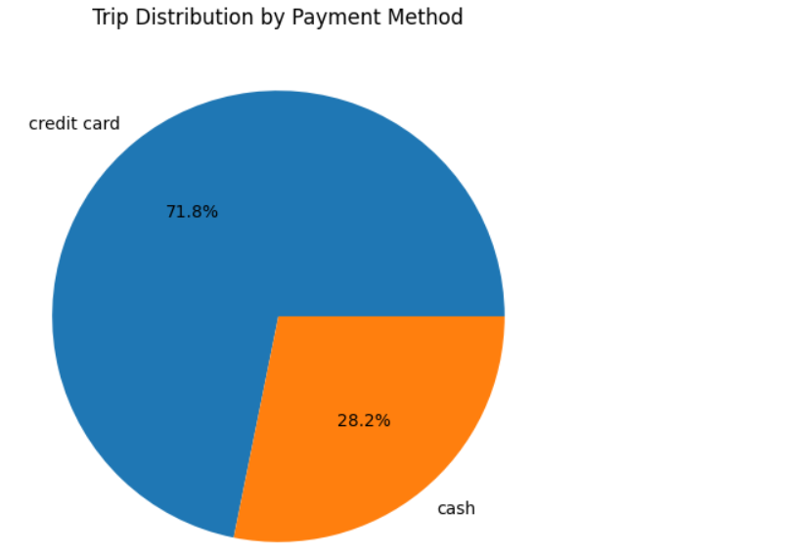

★ Histogram
Create a histogram to visualize the distribution of distance. Customize the number of bins for better granularity and ensure the plot is easy to interpret.

PYTHON CODE WITH OUTPUT
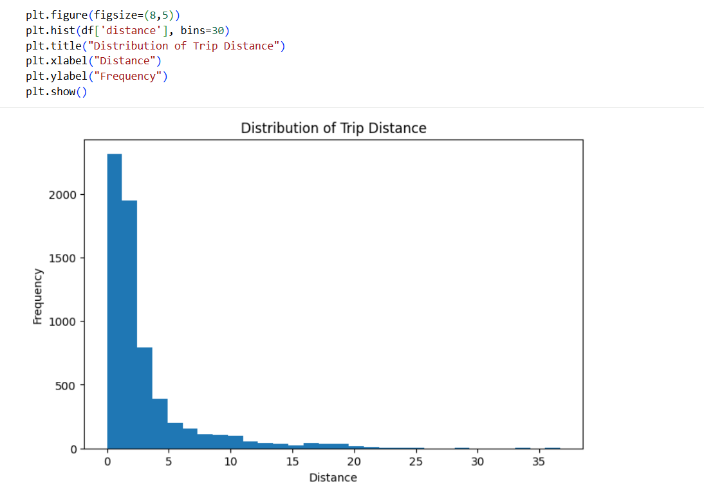
★ Box Plot
Plot a box plot to visualize the distribution of tip amounts for each pickup_borough. Use pickup_borough as the categorical axis and tip as the numeric axis.

PYTHON CODE WITH OUTPUT
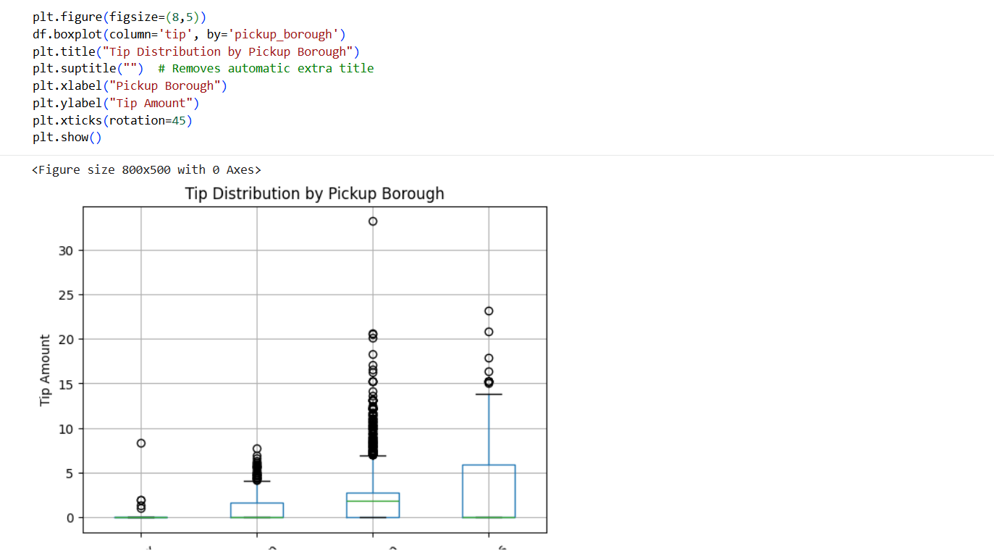
Visualizations using Seaborn:
★ Count Plot
Create a count plot to visualize the number of trips in each pickup_borough. The x-axis should represent the boroughs, and the y-axis should show the count of trips.

PYTHON CODE WITH OUTPUT
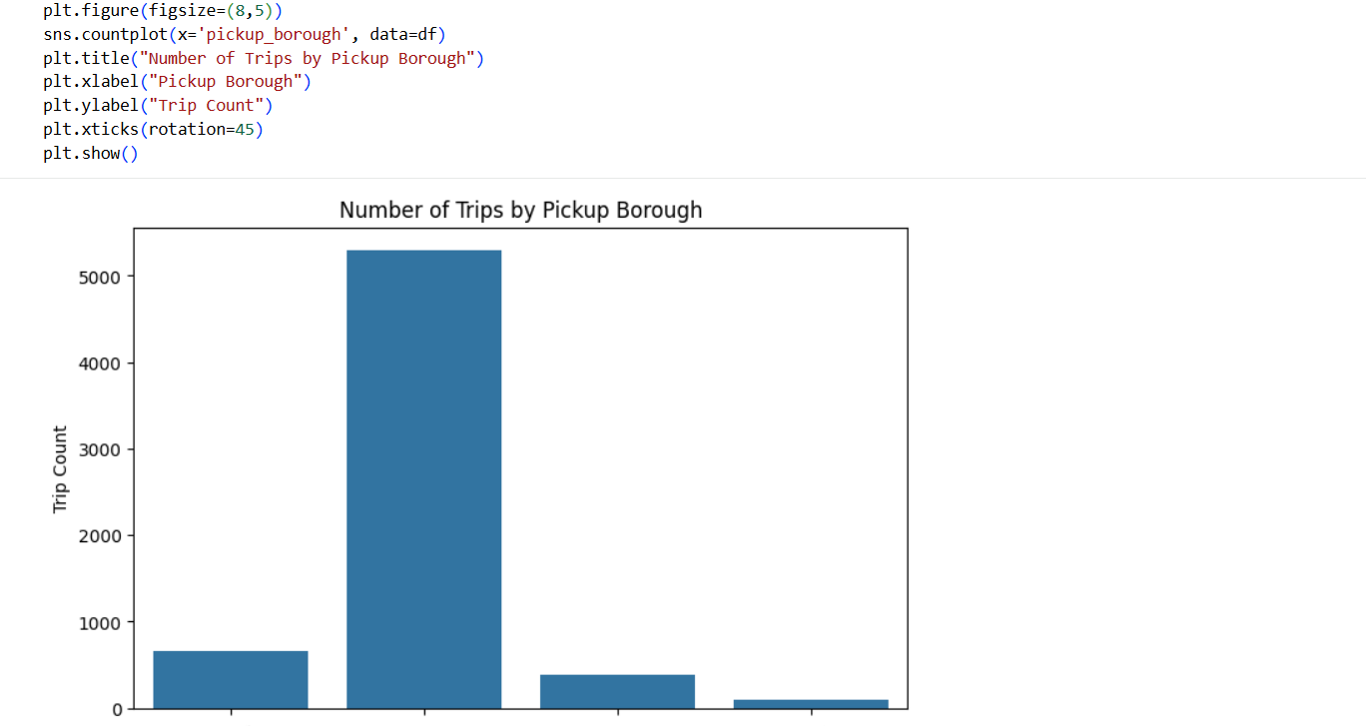
★ Scatter Plot
Plot a scatter plot to show the relationship between distance and fare. Use distance on the x-axis and fare on the y-axis to visualize any correlation. Color the points based on the pickup_borough to differentiate the trips by their respective boroughs.

PYTHON CODE WITH OUTPUT
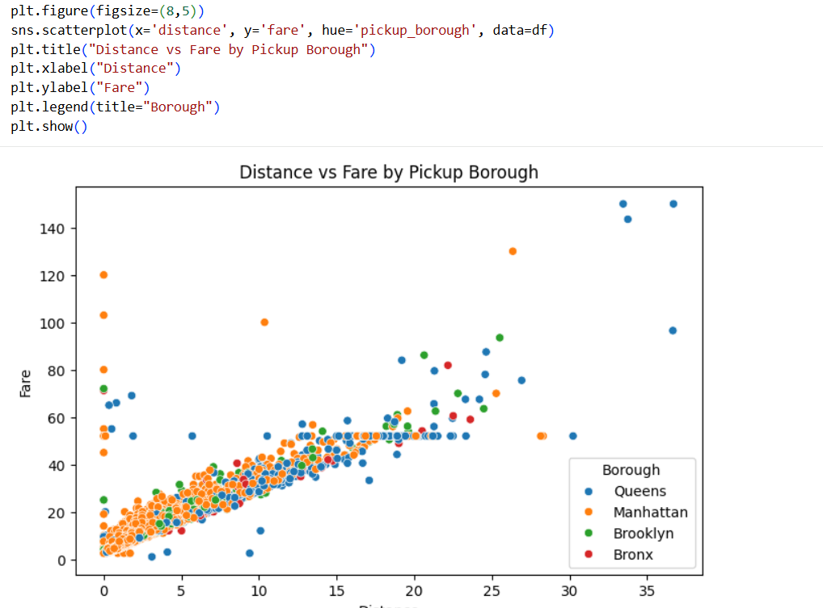
★ Heatmap
Plot a heatmap to visualize the correlation between numerical variables such as distance, fare, tip, tolls, and total. Use a correlation matrix to highlight the relationships.

PYTHON CODE WITH OUTPUT
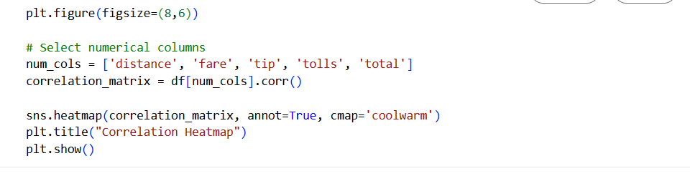
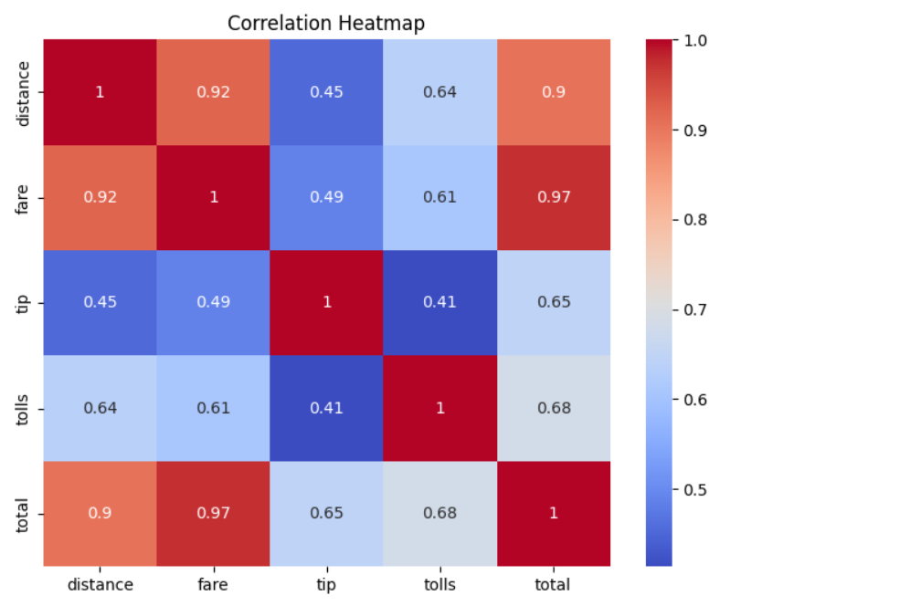

★ Pair Plot
Create a pair plot to visualize the pairwise relationships between distance, fare, tip, and total. Color the data points according to the pickup_zone method to compare how different zones affect these variables.

PYTHON CODE WITH OUTPUT
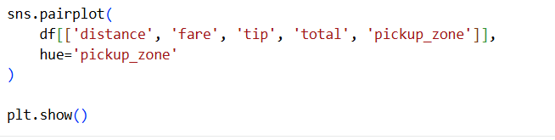

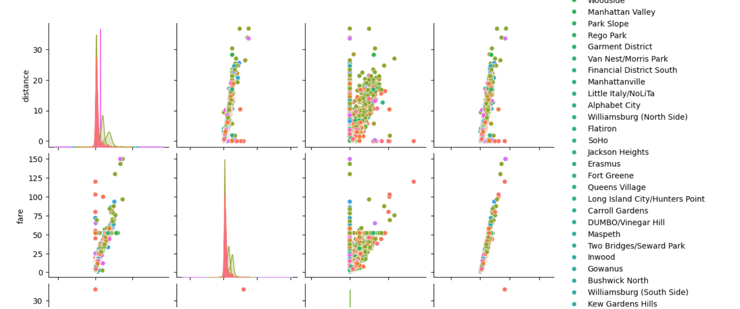

★ Violin Plot
Plot a violin plot to show the distribution of fare for each payment method. Use the payment method as the categorical axis and fare as the numeric axis to visualize its distribution.

PYTHON CODE WITH OUTPUT
